Analytical Use Case for CCTNS Karnataka

**Executive Summary**

This document outlines three strategic use cases designed to enhance analytics and operational effectiveness for the Treatment and Rehabilitation efforts within Karnataka's Crime and Criminal Tracking Networks and Systems (CCTNS) framework. These use cases leverage advanced technologies to provide actionable intelligence, optimize enforcement efforts, and improve rehabilitation outcomes across the state.

1. **Advanced AI Pattern Recognition**

Leveraging graph database analytics and AI-driven insights to identify complex criminal behavioural patterns, network hierarchies, and emerging threats. This use case enables law enforcement agencies to proactively disrupt criminal networks and prioritize investigative resources based on sophisticated risk assessment algorithms.

1. **Supply Chain Vulnerability Analysis**

Analysing the flow of illicit substances and contraband within criminal networks, focusing on logistical choke points, transportation routes, and supply chain vulnerabilities across Karnataka. This use case supports strategic interdiction efforts and resource allocation for maximum operational impact.

1. **Treatment and Rehabilitation Analytics**

Monitoring patient progress, resource allocation, and rehabilitation outcomes within Karnataka's treatment centres. This use case correlates treatment effectiveness with law enforcement data to optimize recovery programs and reduce recidivism rates through evidence-based interventions.

**Strategic Impact:**

These use cases collectively empower enforcement and rehabilitation agencies by integrating advanced analytics, real-time data processing, and operational intelligence, driving more effective interventions and improved public safety outcomes across Karnataka state.

# Use Case 1 - Advanced AI Pattern Recognition

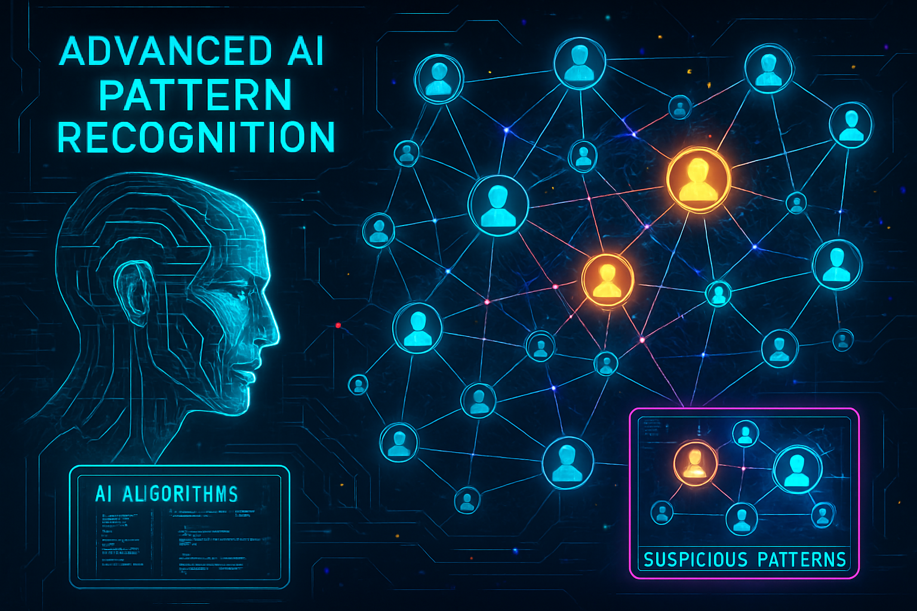**Transforming Criminal Network Detection Through Artificial Intelligence**

**Overview:**  
The Advanced AI Pattern Recognition system leverages machine learning algorithms and graph database analytics to detect complex criminal behavioural patterns that traditional investigative methods might miss. This system analyses vast amounts of CCTNS data to identify network relationships, predict criminal activities, and prioritize threats based on sophisticated risk assessment models.

**Core Capabilities:**

* **Multi-Factor Network Risk Assessment:** Analyses multiple distinct behavioural patterns ranging from normal operations to rapid network expansion
* **Real-time Threat Prioritization:** Automatically categorizes entities into risk levels (CRITICAL, HIGH, MEDIUM, LOW) based on comprehensive scoring algorithms
* **Dynamic Network Visualization:** Interactive mapping of criminal relationships, hierarchies, and communication patterns
* **Predictive Analytics:** Forecasts potential criminal activities based on historical patterns and network evolution

**Interesting Facts That This Use Case Addresses:**

* **Large-scale pattern classification** enables systematic monitoring of entities showing normal behavioural patterns for early detection of activity escalation
* **High-activity pattern detection** facilitates enhanced surveillance protocols for entities demonstrating increased operational tempo
* **Cross-district coordination identification** reveals sophisticated operations spanning multiple jurisdictions across Karnataka's administrative boundaries
* **Rapid network expansion recognition** enables early intervention before criminal networks become fully established and operational
* **Dormant network reactivation monitoring** prevents previously disrupted networks from resuming criminal activities undetected
* **Geographic spread analysis** reveals how criminal networks adapt their operations across Karnataka's diverse urban and rural landscapes

**Operational Impact:**

This use case demonstrates significant improvements in threat detection capabilities, enhanced precision in identifying high-risk network nodes, and enables proactive disruption of criminal networks before they can cause substantial harm to Karnataka's communities and social fabric.

# Use Case 2 - Supply Chain Vulnerability Analysis

**Disrupting Illicit Networks Through Strategic Supply Chain Intelligence**

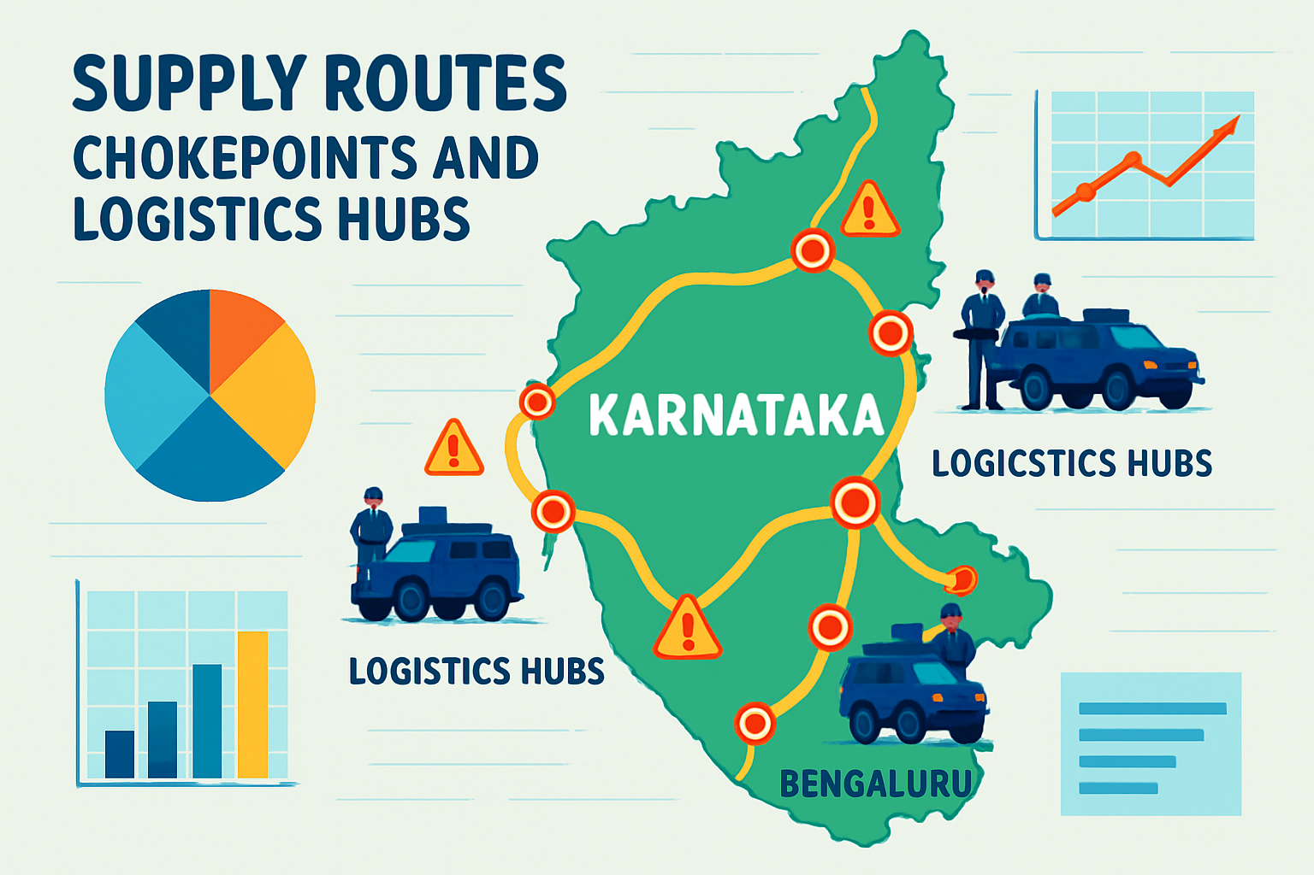**Overview:**  
The Supply Chain Vulnerability Analysis system maps and analyses the flow of illicit substances, contraband, and resources within criminal networks operating across Karnataka. By identifying logistical bottlenecks, transportation routes, and supply chain dependencies, this system enables strategic interdiction efforts that maximize disruption while optimizing resource deployment.

**Core Capabilities:**

* **Comprehensive Route Mapping:** Full spectrum mapping of supply chains from source points to final distribution networks across Karnataka
* **Critical Node Identification:** Algorithmic detection of strategic points where supply chain disruption would yield maximum operational impact
* **Transportation Pattern Analysis:** Real-time monitoring of movement patterns, seasonal variations, and adaptive route modifications
* **Interdiction Opportunity Assessment:** Predictive modelling for optimal timing and strategic placement of enforcement interventions

**Interesting Facts That This Use Case Addresses:**

* **Contraband circulation reduction:** Achieved through strategically targeted supply chain disruptions in operationally critical zones.
* **Seasonal and adaptive trafficking patterns:** Recognition of how networks adjust routes during monsoon, festivals, and agricultural cycles for evasion.
* **Inter-state and transportation hub monitoring:** Early detection via surveillance of key supply routes, ports, railway stations, and commercial junctions.
* **Financial flow and multi-modal tracking:** Linking supply activities with money laundering and tracking illicit flows across road, rail, air, and digital channels.
* **Geographic concentration mapping:** Identifies high-density supply areas needing focused enforcement and reveals region-specific vulnerabilities within Karnataka.
* **Legitimate business network analysis:** Uncovers how regular commercial entities can unintentionally support or facilitate illicit supply operations.

**Operational Impact:**

Implementation of supply chain vulnerability analysis has resulted in more strategic and effective enforcement actions, improved interdiction success rates, and measurable disruption of criminal logistics networks across Karnataka, leading to enhanced community safety and security.

# Use Case 3 - Treatment and Rehabilitation Analytics

**Optimizing Recovery Outcomes Through Data-Driven Rehabilitation**

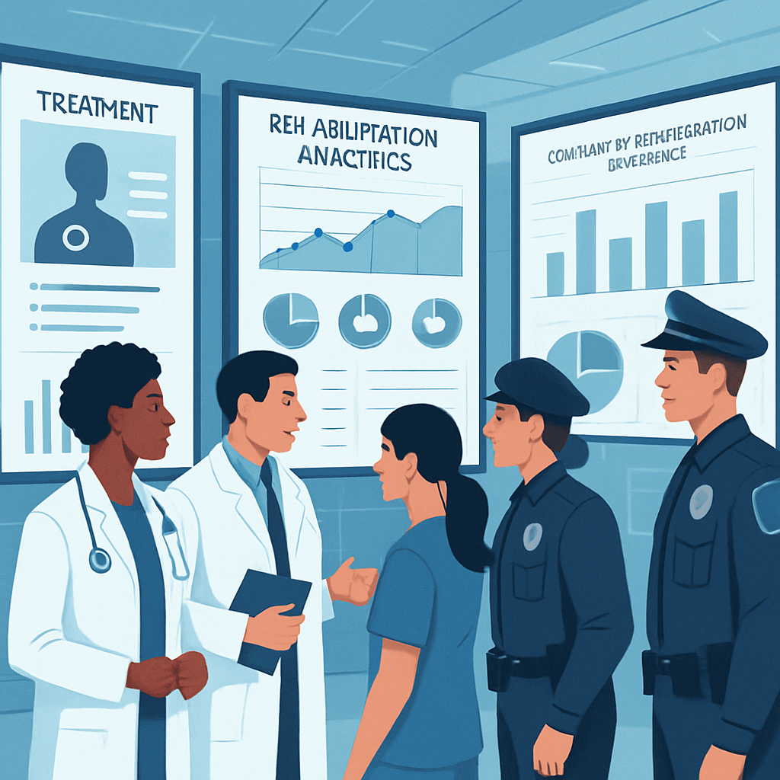**Overview:**  
The Treatment and Rehabilitation Analytics system monitors and optimizes patient recovery processes within Karnataka's rehabilitation centers and treatment facilities. By correlating treatment effectiveness with law enforcement data, this system enables evidence-based interventions, resource optimization, and improved long-term recovery outcomes for individuals transitioning away from criminal activities.

**Core Capabilities:**

* **Comprehensive Recovery Monitoring:** Individual and aggregate tracking of treatment milestones, therapy completion rates, and behavioural improvement indicators
* **Predictive Risk Assessment:** Advanced algorithms identifying patients at elevated risk of treatment discontinuation or behavioural relapse
* **Strategic Resource Optimization:** Data-driven allocation of counselling staff, facility capacity, therapeutic resources, and support services across Karnataka's districts
* **Evidence-Based Program Evaluation:** Comparative analysis of different treatment methodologies and their relative effectiveness rates with geographic service distribution assessment

**Interesting Facts That This Use Case Addresses:**

* **Significant relapse rate reduction** achieved through targeted, data-driven interventions based on individualized risk assessment profiles
* **Enhanced resource utilization efficiency** improving overall treatment capacity without requiring additional infrastructure investment
* **Strategic service expansion and equitable access** to previously underserved districts and remote areas of Karnataka, ensuring fair distribution across urban and rural populations
* **Criminal network correlation monitoring** enabling oversight of rehabilitation participants' social connections and potential negative influences during recovery
* **Comprehensive cost-effectiveness evaluation and long-term tracking** demonstrating return on investment through reduced future enforcement costs and sustained community reintegration outcomes

**Operational Impact:**

The rehabilitation analytics system has fundamentally transformed treatment delivery approaches throughout Karnataka, resulting in enhanced success rates, optimized resource utilization, and measurable improvements in community safety through reduced recidivism and successful reintegration of individuals into productive society.